Measurement Precision
# Source: AI Source: Provided by: [Data Path: Persons Table -> ID Column: 1, Name_En Column: Motasem Essam] -> From: [ChatGPT] on [7/17/2026]
Measurement Precision is the degree to which repeated measurements of the same quantity under the same conditions agree with one another. It indicates the consistency or repeatability of measurements, regardless of whether they are close to the true value.
Precision is one of the most important characteristics of measurement systems and is fundamental in science, engineering, manufacturing, medicine, metrology, quality control, and laboratory work.

Definition
# Source: AI Source: Provided by: [Data Path: Persons Table -> ID Column: 1, Name_En Column: Motasem Essam] -> From: [ChatGPT] on [7/17/2026]
Measurement Precision is the closeness of agreement among repeated measurements of the same quantity made under identical conditions.
A set of measurements is considered highly precise if the measured values are very close to each other.

Purpose
# Source: AI Source: Provided by: [Data Path: Persons Table -> ID Column: 1, Name_En Column: Motasem Essam] -> From: [ChatGPT] on [7/17/2026]
Measurement precision is used to:
- Evaluate the consistency of measurements.
- Assess instrument repeatability.
- Improve quality control.
- Reduce measurement variability.
- Support scientific research.
- Verify manufacturing processes.
- Increase confidence in measurement results.

Characteristics
# Source: AI Source: Provided by: [Data Path: Persons Table -> ID Column: 1, Name_En Column: Motasem Essam] -> From: [ChatGPT] on [7/17/2026]
A precise measurement is:
- Consistent.
- Repeatable.
- Reproducible under similar conditions.
- Less affected by random errors.
- Stable over repeated measurements.

Example
# Source: AI Source: Provided by: [Data Path: Persons Table -> ID Column: 1, Name_En Column: Motasem Essam] -> From: [ChatGPT] on [7/17/2026]
Suppose the true length of an object is 100.00 cm.
Example 1 – High Precision
Repeated measurements:
- 98.01 cm
- 98.02 cm
- 98.00 cm
- 98.01 cm
These measurements are highly precise because they are very close to one another, even though they are not close to the true value.

Example 2 – Low Precision
Repeated measurements:
- 95.4 cm
- 99.8 cm
- 102.1 cm
- 97.6 cm
These measurements are not precise because they vary considerably.

Factors Affecting Precision
# Source: AI Source: Provided by: [Data Path: Persons Table -> ID Column: 1, Name_En Column: Motasem Essam] -> From: [ChatGPT] on [7/17/2026]
Measurement precision depends on:
- Instrument quality.
- Instrument resolution.
- Environmental stability.
- Measurement technique.
- Operator consistency.
- Random errors.
- Instrument repeatability.

Improving Precision
# Source: AI Source: Provided by: [Data Path: Persons Table -> ID Column: 1, Name_En Column: Motasem Essam] -> From: [ChatGPT] on [7/17/2026]
Precision can be improved by:
- Using high-quality measuring instruments.
- Increasing instrument resolution.
- Reducing random errors.
- Maintaining stable environmental conditions.
- Using consistent measurement procedures.
- Training operators.

Sources of Poor Precision
# Source: AI Source: Provided by: [Data Path: Persons Table -> ID Column: 1, Name_En Column: Motasem Essam] -> From: [ChatGPT] on [7/17/2026]
Common causes include:
- Random errors.
- Instrument instability.
- Environmental vibration.
- Temperature fluctuations.
- Human inconsistency.
- Electrical noise (for electronic instruments).

Applications
# Source: AI Source: Provided by: [Data Path: Persons Table -> ID Column: 1, Name_En Column: Motasem Essam] -> From: [ChatGPT] on [7/17/2026]
Measurement precision is essential in:
- Scientific research
- Engineering
- Manufacturing
- Quality assurance
- Medicine
- Metrology
- Electronics
- Aerospace
- Chemistry
- Physics

Everyday Examples
# Source: AI Source: Provided by: [Data Path: Persons Table -> ID Column: 1, Name_En Column: Motasem Essam] -> From: [ChatGPT] on [7/17/2026]
Examples include:
- Repeatedly weighing an object on a digital balance.
- Measuring body temperature several times.
- Recording lap times with a stopwatch.
- Measuring a board with a caliper.
- Checking tire pressure repeatedly.

Precision vs. Accuracy
# Source: AI Source: Provided by: [Data Path: Persons Table -> ID Column: 1, Name_En Column: Motasem Essam] -> From: [ChatGPT] on [7/17/2026]
Precision and accuracy are related but not the same.
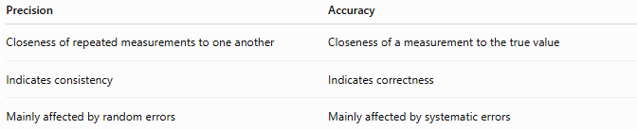
Precision | Accuracy
Closeness of repeated measurements to one another | Closeness of a measurement to the true value
Indicates consistency | Indicates correctness
Mainly affected by random errors | Mainly affected by systematic errors
High Precision, Low Accuracy
True value = 100.00 cm
Measurements:
- 98.01 cm
- 98.02 cm
- 98.00 cm
These measurements are precise but not accurate.

High Precision, High Accuracy
# Source: AI Source: Provided by: [Data Path: Persons Table -> ID Column: 1, Name_En Column: Motasem Essam] -> From: [ChatGPT] on [7/17/2026]
True value = 100.00 cm
Measurements:
- 100.00 cm
- 100.01 cm
- 99.99 cm
These measurements are both accurate and precise.

Precision vs. Repeatability
# Source: AI Source: Provided by: [Data Path: Persons Table -> ID Column: 1, Name_En Column: Motasem Essam] -> From: [ChatGPT] on [7/17/2026]
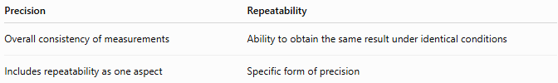
Precision | Repeatability
Overall consistency of measurements | Ability to obtain the same result under identical conditions
Includes repeatability as one aspect | Specific form of precision

Precision vs. Resolution
# Source: AI Source: Provided by: [Data Path: Persons Table -> ID Column: 1, Name_En Column: Motasem Essam] -> From: [ChatGPT] on [7/17/2026]
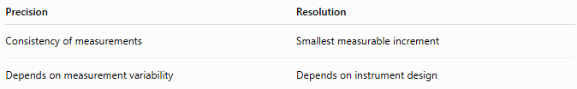
Precision | Resolution
Consistency of measurements | Smallest measurable increment
Depends on measurement variability | Depends on instrument design
An instrument may have high resolution but still produce poor precision if repeated measurements vary significantly.

Precision vs. Reproducibility
# Source: AI Source: Provided by: [Data Path: Persons Table -> ID Column: 1, Name_En Column: Motasem Essam] -> From: [ChatGPT] on [7/17/2026]
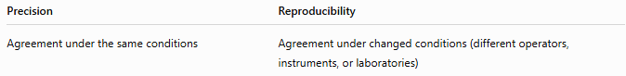
Precision | Reproducibility
Agreement under the same conditions | Agreement under changed conditions (different operators, instruments, or laboratories)

Importance
# Source: AI Source: Provided by: [Data Path: Persons Table -> ID Column: 1, Name_En Column: Motasem Essam] -> From: [ChatGPT] on [7/17/2026]
Measurement precision:
- Improves product quality.
- Reduces variability.
- Supports reliable scientific results.
- Enhances manufacturing consistency.
- Builds confidence in measurements.
- Detects random errors.

Common Mistakes
# Source: AI Source: Provided by: [Data Path: Persons Table -> ID Column: 1, Name_En Column: Motasem Essam] -> From: [ChatGPT] on [7/17/2026]
- Confusing precision with accuracy.
- Assuming consistent measurements are always correct.
- Ignoring environmental effects.
- Using unstable measuring instruments.
- Misinterpreting high resolution as high precision.

Key Points
# Source: AI Source: Provided by: [Data Path: Persons Table -> ID Column: 1, Name_En Column: Motasem Essam] -> From: [ChatGPT] on [7/17/2026]
- Precision is the closeness of repeated measurements to one another.
- High precision indicates consistency, not necessarily correctness.
- Precision is mainly affected by random errors.
- Precision differs from accuracy, resolution, and reproducibility.
- High precision is essential for scientific, industrial, and engineering measurements.

Conclusion
# Source: AI Source: Provided by: [Data Path: Persons Table -> ID Column: 1, Name_En Column: Motasem Essam] -> From: [ChatGPT] on [7/17/2026]
Measurement Precision is the degree of agreement among repeated measurements of the same quantity made under identical conditions. It reflects the consistency and repeatability of a measurement process rather than its closeness to the true value. High precision is achieved by minimizing random errors, using stable and high-quality instruments, maintaining controlled environmental conditions, and following consistent measurement procedures. Precision is a fundamental characteristic of reliable measurement systems and plays a vital role in science, engineering, manufacturing, healthcare, and quality control.

